**GAS LEAKAGE MONITORING AND LEAKAGE SYSTEM**

**ASSIGNMENT 1**:

Make a Smart Home in Tinkercad, using 2+ sensors, Led, Buzzer in single code and circuit.

**SIMULATION:**

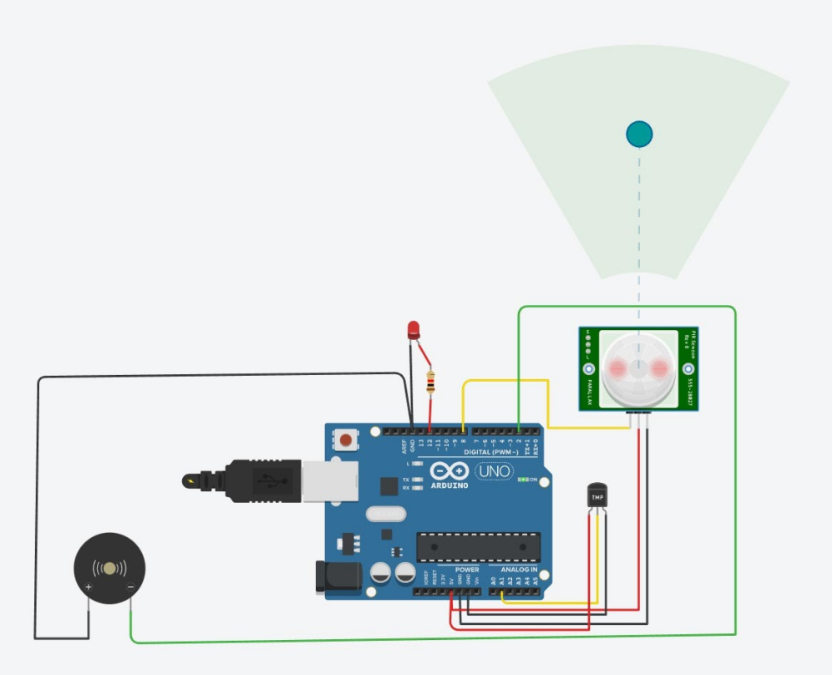

**CODE:**

// C++ code

// void setup()

{

pinMode(12, OUTPUT);

pinMode(2,OUTPUT); }

void loop()

{

int m=digitalRead(8);

double a=analogRead(A1);

double v=a/1024;

double tvolt=v*5;

double o=tvolt-0.5;

double t=o*100; if(t>50)

{

digitalWrite(2, HIGH);

}

else

{

digitalWrite(2, LOW);

}

if(m==1)

{

digitalWrite(12, HIGH);

}

else

{

digitalWrite(12, LOW);

}

}